New B3 Fixed Income Trading Environment

B3 OTC Participants

Access, Registration and Connectivity Documents for the New B3 Fixed Income Trading Subsystem

The registration authorization processes, platform installation and specifications are described below and are available in this document, which will be periodically updated by B3. The version change log and updates are available in the attached document.

Registration

The registration structure of the new B3 Fixed Income Trading Subsystem uses B3’s Integrated Registration System (SINCAD).

Participants must be registered with SINCAD with an active B3 participant ID and one of the following categories must be enabled:

- Banks:

  - PBAL (B3 OTC Participant): Mandatory registration category for Treasuries that trade directly on the platform.

  - GEST (B3 OTC Manager): Optional registration category for Treasuries that need to trade on behalf of their proprietary funds.

- Brokerage Houses:

  - PBAL (B3 OTC Participant): Mandatory registration category for Brokerage Houses that trade directly on the platform.

  - GEST (B3 OTC Manager): Optional registration category for Brokerage Houses that need to trade on behalf of funds under their management or not.

  - PN (Trading Participant): A mandatory registration category for Brokerage Houses that trade directly on the platform.

  - PNP (Full trading Participant): A mandatory registration category for Brokerage Houses wishing to execute automated matched transactions directly on the platform, for their own positions and for third-party positions (intermediation).

- Buyside:

  - GEST (B3 OTC Manager): A mandatory registration category for Managers, Administrators, Funds, Pension Funds, Insurance Companies and Investment Clubs that need to trade directly on the platform .

- Non-Financial Corporate Investor:

  - Visualizers: Optional access category for non-financial corporate investors that need to view public offerings on the platform. Unmanaged access category of B3's Integrated Registration System (SINCAD) and upon query permits only. Access will be carried out exclusively via web page.

Institutions not registered with SINCAD must open the procedure for creating accounts through B3’s registration service via one of the following channels:

  - Atende B3 Portal: https://atendimento.b3.com.br/atendeb3

  - Email: cadastro@b3.com.br

Further information is available from B3’s registration page:
https://www.b3.com.br/pt_br/produtos-e-servicos/participantes/mercado-de- balcao/abertura-de-conta/

Access Management

Access management of the new B3 Fixed Income Trading Subsystem is carried out via B3's Unified Access Control (CAU) system, where the institution's privileged user is responsible for creating and maintaining common platform users.

For current Trader Platform users (one-time procedure):
  - For institutions that are active in production on the Trader Platform and with one access in the last 6 months, B3 will automatically add users to the new subsystem in the certification and production environment. For institution’s users who are already registered with B3's CAU system, the login remains the same as the existing one and is also valid for accessing the new B3 Fixed Income Trading Environment. For users not registered with CAU, the system will automatically send access credentials to users via email (user login and temporary password). The process will be carried out one week before the certification period and one week before the start of production with prior communication sent by B3.

  - Subsequent to this initial load in each of the mentioned environments, management of existing and new accesses shall be the responsibility of the privileged user of the institution registered with CAU.

For privileged users of institutions wishing to bring forward or test access and interaction with B3's CAU system, below is a guide to the steps of the procedure for accessing and adding ordinary users.

Access Profile Matrix

Profile | Permits
B3FI_OPERADOR-SUPERVISOR_BVMF | Full access profile to trading and with jurisdiction to register and alter limits for counterparties trading
B3FI_OPERADOR _BVMF | Full access profile to trading
B3FI_COMPLIANCE-RISCO_BMVF | Access profile to queries and limit registration for traders
B3FI_BACKOFFICE_ BMVF | Access profile to queries and to the platform’s public book
B3FI_CONSULTADOR_ BMVF | Visualization profile of the public book only

  - CAU access link RCB Certification: Only for access from the CAU portal https://cau.cert.bvmfnet.com.br/portalbvmf/

  - CAU internet access link: Request access permission and instructions by email produtosrendafixa@b3.com.br, access link via https://cau- cert.b3.com.br/cauwebportal – For internet access, also follow the authorization script for the second CAU authentication factor available on the B3 Clients website project page

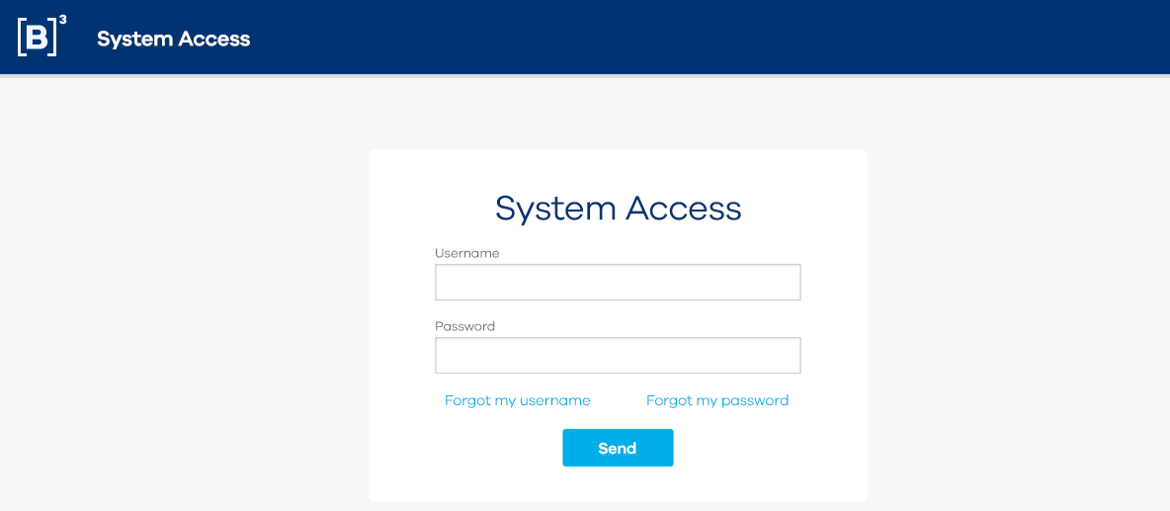

Continue from this point after the previous procedure has been carried out, regardless of the access format chosen by the user/institution.

System: Unified Access Control (CAU)

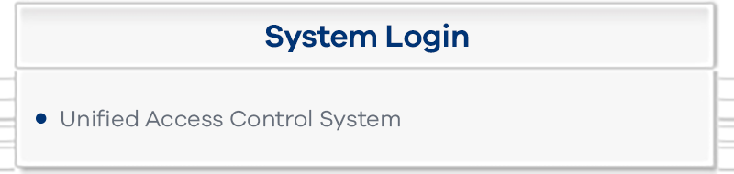
- For new users, the ordinary user is first added to the platform from the menu below.

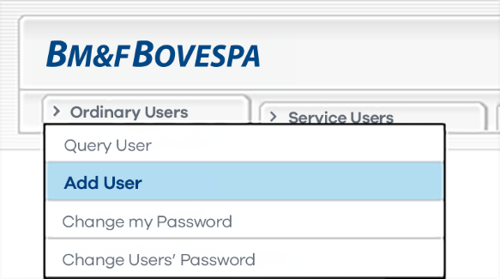

- For existing users, continue from the step below:
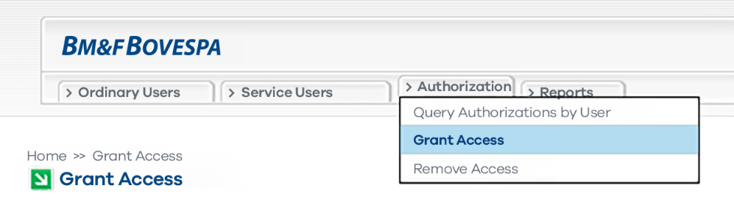

- Add user who will receive access permission and then click on Query

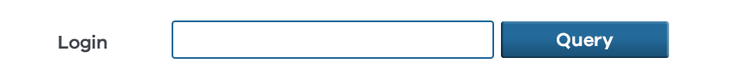

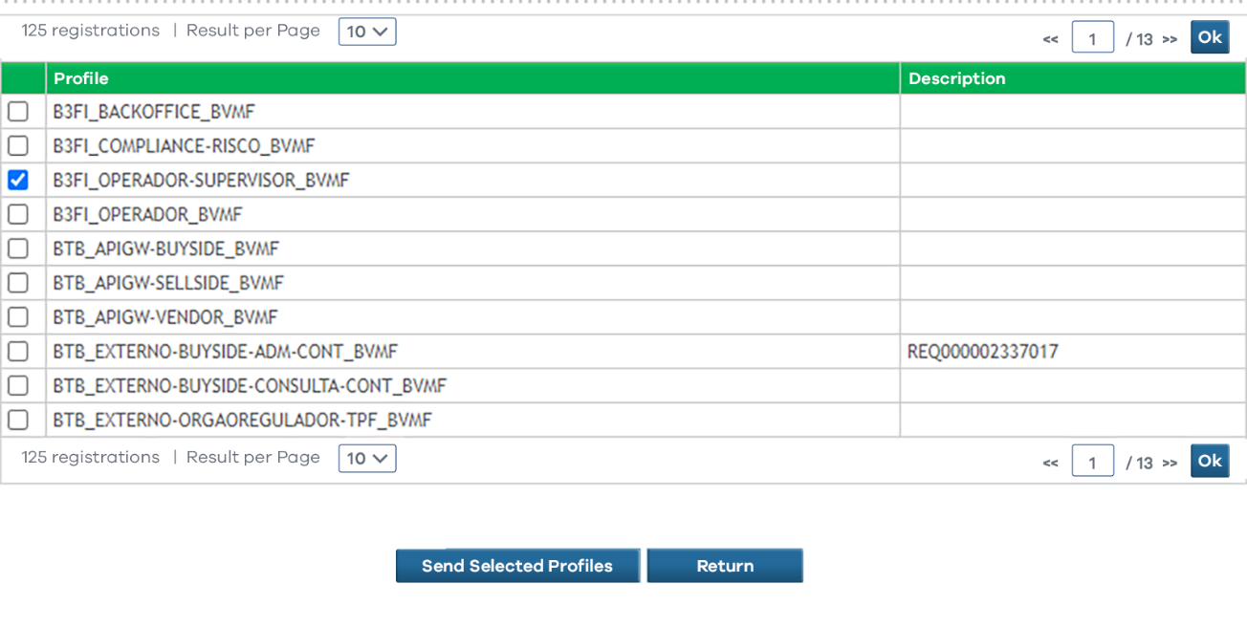
- Search the list of available profiles for the options related to B3FI and select the respective access and permission required for that user:

- Confirm execution of the transaction via the message below:

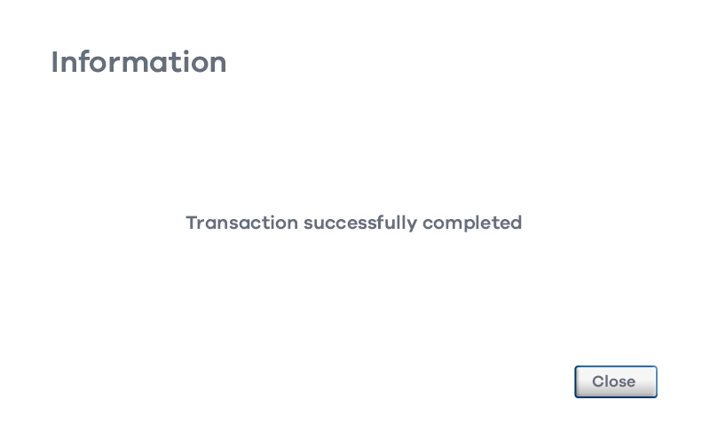

Platform Requirements, Installation and Connectivity:

Platform execution requirements:

  - Microsoft .NET SDK 6.0 (full version or runtime) Installation:
Via CAU internet using the link: https://cau-cert.b3.com.br/api/b3fi-installer-download

Via CAU RCB:

- To install the new trading subsystem, the participant must download the system via the link available on B3's Unified Access Control (CAU):

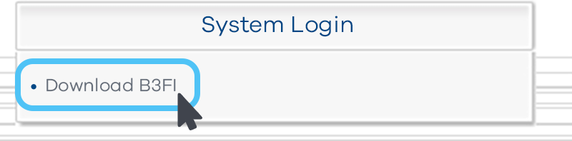

- After clicking on the previous link, the system will automatically provision the platform installer download:

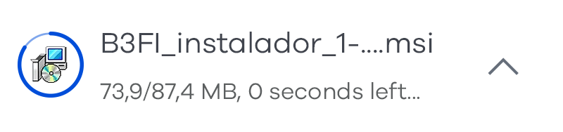

- For the platform installation, set up the installer and follow the steps below:

  - Proceed with the installation

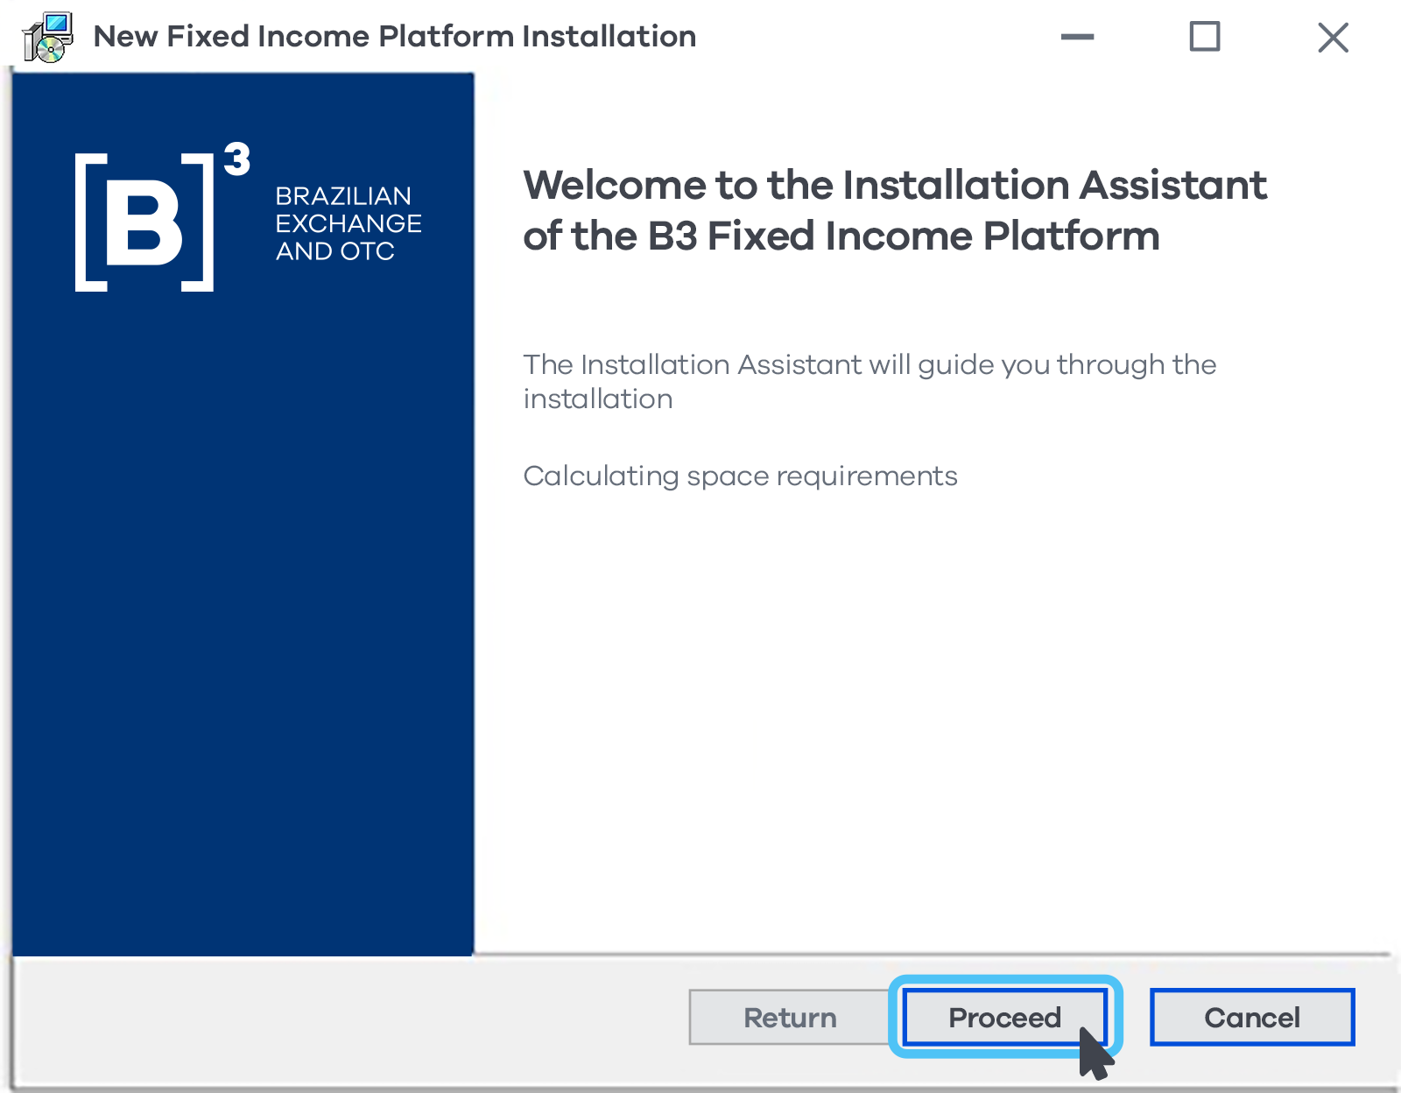

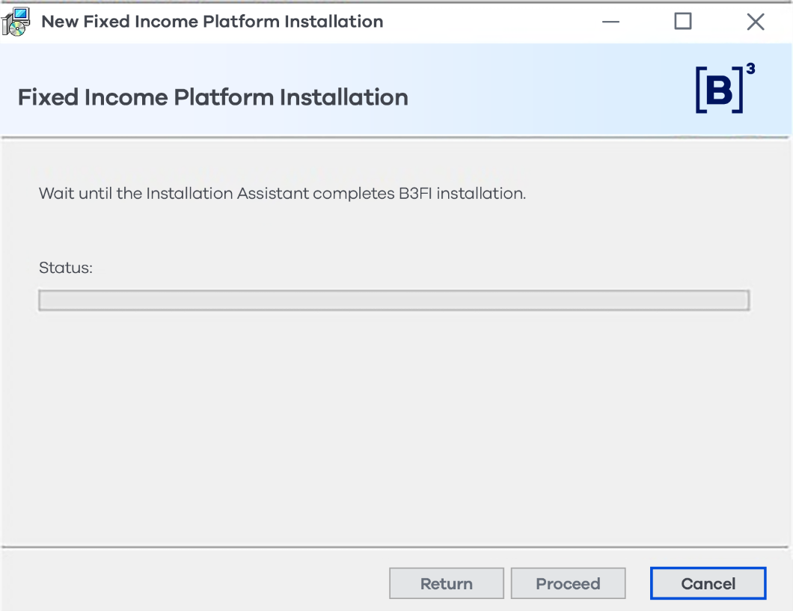

    - Wait for the installation to complete
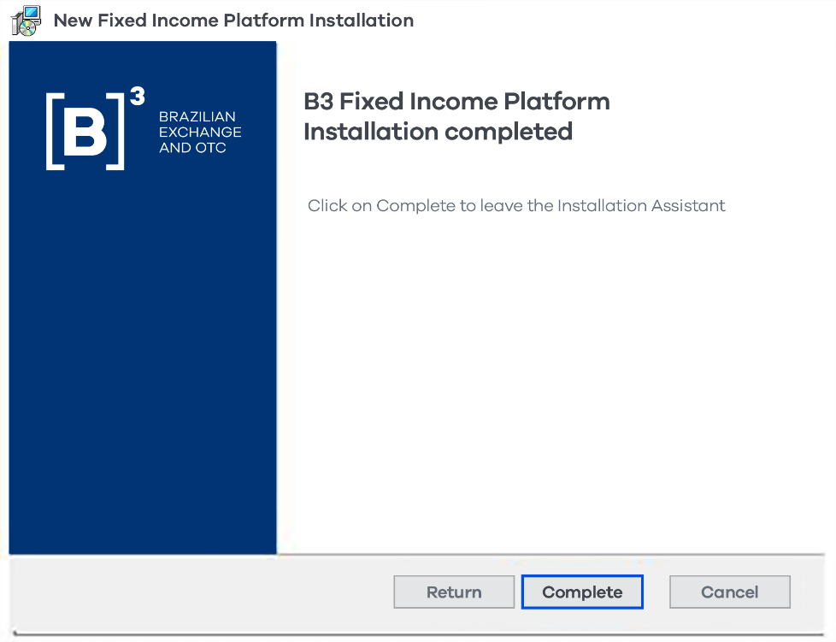

The platform becomes available on the Windows startup menu:



The download is available to all users registered on the platform via B3's Unified Access Control (CAU). Support from the institution's IT team is recommended for installation.

Desktop Client Connectivity:

  - For access via RTM network:

System | URL | Port
Fixed Income Platform | b3fi-cert.rtm.netb3.com.br | 7023/10001/5016
Unified Access Control (CAU) | api-balcao-cert.rtm.netb3.com.br | 443

  - For access via internet:

System | URL | Port
Fixed Income Platform | https://b3fi-cert.b3.com.br | 7023/10001/5016
Unified Access Control (CAU) | api-balcao-cert.b3.com.br | 443
  - For access via RCB:

In progress, will be available at a later date to be announced by B3

B3 recommends principal access via RTM and secondary access via internet for institutions with large trading volumes in the Federal Government Bonds market.

For further questions and/or clarifications, please contact B3's Certification department by telephone on +55 11 2565-5023 (option 2 -3) or by email at tradingcertification@b3.com.br.

